Main Diagram

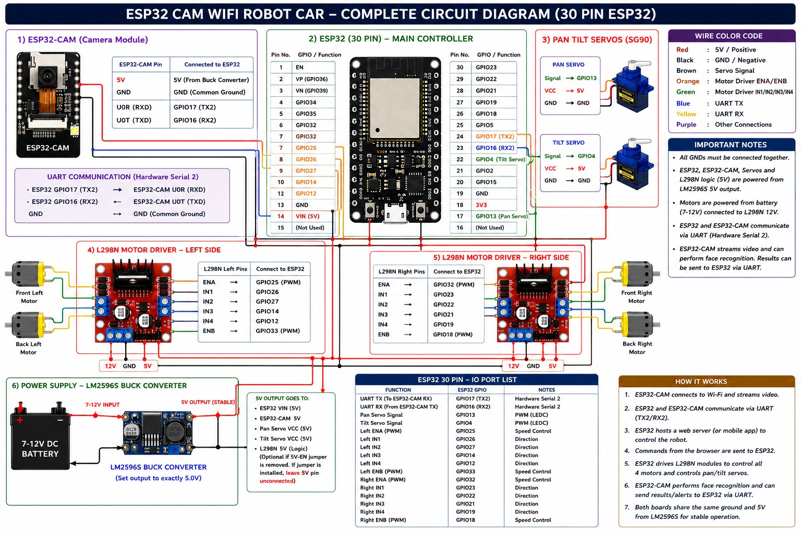

ESP32-CAM-Connection with hardware

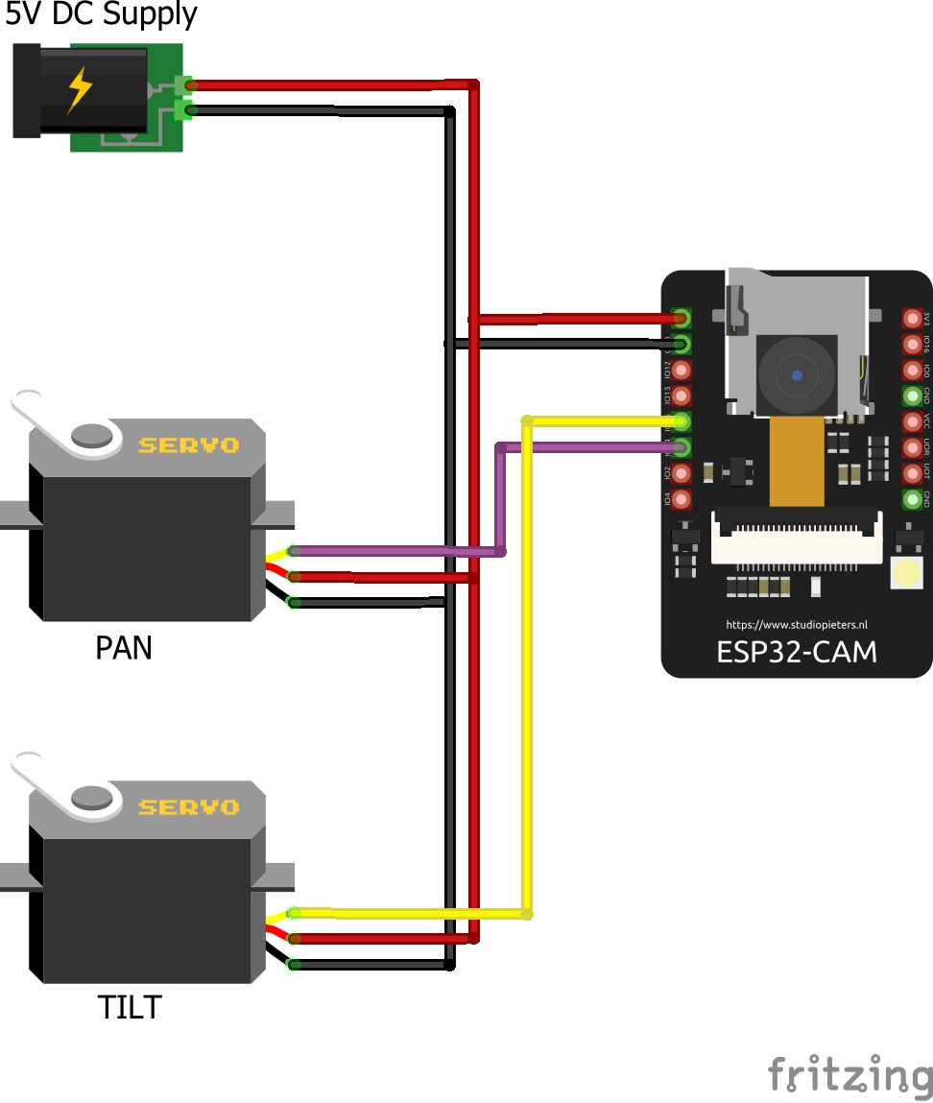
ESP32-CAM Code Upload Diagram
- Must connect arduino reset pin with arduino gnd

